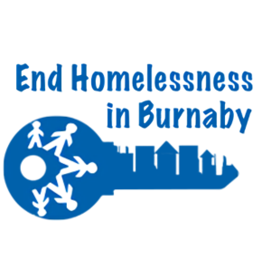

Burnaby Task Force and The Society To End Homelessness In Burnaby
Working Together To End Homelessness In Burnaby

VOLUNTEER APPLICATION (SPECIAL EVENTS) PAGE 1

Name: _____________________ _____________________
(last) (first)

Address: _____________________________________

City: __________________ Postal Code: __________

Telephone: __________________________ Email: __________________________

Event: Connect: ORC Homeless Action Week (HAW)

Have you volunteered for The Society To End Homelessness In Burnaby before? Yes / No

Did you volunteer with a group? _______________
If so, who? _______________

Would you like to be contacted again to volunteer? Yes / No

If you need a confirmation that you have volunteered for us and the number of hours you volunteered, please initial here: ________

The Society To End Homelessness In Burnaby respects and upholds an individual’s right to privacy. Your information/application will be maintained as confidential, secure records. Please note that in order to determine eligibility as a volunteer with our program it is necessary to collect the above information and supporting documentation. In accordance with The Society To End Homelessness In Burnaby Privacy Policy, the personal information you provide will be used to process your application and assess you eligibility. We will not use or disclose this information for any additional purposes unless we obtain consent from you to do so.

Signature: _______________________________________________ Date: ____________________

Parent/Guardian: __________________________________________ Date:____________________

VOLUNTEER APPLICATION (SPECIAL EVENTS) PAGE 2

By agreeing to volunteer with The Society To End Homelessness In Burnaby you are agreeing to meet the following expectations:
1. To arrive at your volunteer placement on time and stay until the end of your shift.
2. To know what is expected from you on the day of the event.
3. To engage with the public.
4. Be mindful that you are representing The Society To End Homelessness In Burnaby and conduct
yourself in an appropriate manner.
5. We encourage you to dress appropriately for the event.
6. Unless you are on a break we request that you are not on your phone.
7. If you demonstrate an unwillingness to participate in the event we have the right to ask you to leave
and also can refuse to send a letter of volunteer hours.

_____________________________________ ____________________
Name Date

We look forward to having you as part of our volunteer pool and appreciate you giving of your time.

